VEG_figures

Jesse Wood

July 19, 2018

## VEG DATA

setwd("C:/Users/woodj/Documents/GRAD SCHOOL - CLEMSON/Project-Specific/R work/USDA-songbirds/USDA-songbirds")  
  
vdata <-read.csv("template_pcount_csv.csv")  
  
library("ggplot2")  
library("rmarkdown")  
library("markdown")  
library("knitr")  
library("RColorBrewer")  
library("lme4")

## Loading required package: Matrix

library("lmtest")

## Loading required package: zoo

##   
## Attaching package: 'zoo'

## The following objects are masked from 'package:base':  
##   
## as.Date, as.Date.numeric

library("unmarked")

## Loading required package: reshape

##   
## Attaching package: 'reshape'

## The following object is masked from 'package:Matrix':  
##   
## expand

## Loading required package: lattice

## Loading required package: parallel

## Loading required package: Rcpp

##   
## Attaching package: 'unmarked'

## The following object is masked from 'package:lme4':  
##   
## ranef

library("AICcmodavg")

##   
## Attaching package: 'AICcmodavg'

## The following object is masked from 'package:lme4':  
##   
## checkConv

library("quantreg")

## Loading required package: SparseM

##   
## Attaching package: 'SparseM'

## The following object is masked from 'package:base':  
##   
## backsolve

# canopy cover varied significantly by treatment

ccover.lm<-lm(Ccover~Nburns,data=vdata)  
summary(ccover.lm)

##   
## Call:  
## lm(formula = Ccover ~ Nburns, data = vdata)  
##   
## Residuals:  
## Min 1Q Median 3Q Max   
## -23.440 -3.345 1.380 5.066 16.390   
##   
## Coefficients:  
## Estimate Std. Error t value Pr(>|t|)   
## (Intercept) 93.2762 1.4379 64.869 < 2e-16 ***  
## Nburns -1.7805 0.4583 -3.885 0.000307 ***  
## ---  
## Signif. codes: 0 '***' 0.001 '**' 0.01 '*' 0.05 '.' 0.1 ' ' 1  
##   
## Residual standard error: 7.692 on 49 degrees of freedom  
## Multiple R-squared: 0.2355, Adjusted R-squared: 0.2199   
## F-statistic: 15.09 on 1 and 49 DF, p-value: 0.0003072

confint.lm(ccover.lm)

## 2.5 % 97.5 %  
## (Intercept) 90.386606 96.1658018  
## Nburns -2.701537 -0.8594898

plot(ccover.lm)

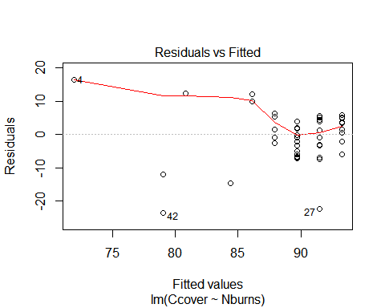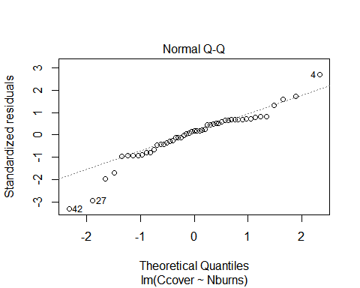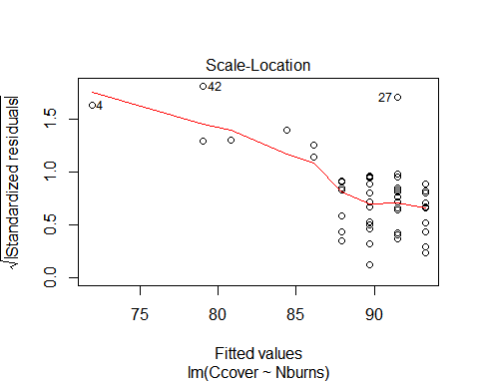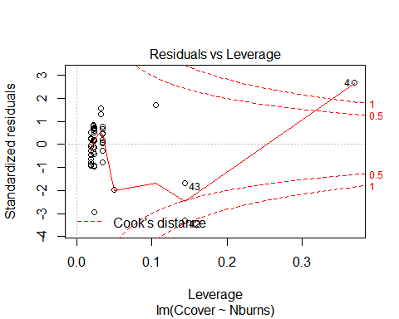

#summary(vdata)  
#levels(vdata$Treatment)  
#display.brewer.all()  
#myColors<-brewer.pal(4,"Greens")  
#names(myColors)<-levels(vdata$Treatment)  
#colScale<-scale_colour_manual(name="Treatment",values=myColors)  
#colScale  
  
#fig+colScale+theme(panel.background = element_rect(fill = "gray",colour = "lightgray",size = 0.5, linetype = "solid"))  
  
#brewer.pal(n=8,name="Greens")  
#palette(brewer.pal(n=4,name="Greens"))  
  
fig<-print(ggplot(vdata,aes(x=Nburns,y=Ccover,colour=Treatment))  
 +geom_jitter()  
 +geom_smooth(method=lm,fullrange=TRUE,color="black",size=0.5)  
 +labs(x="Increasing # of burns",y="Canopy cover (more dense)")  
 +scale_color_brewer(palette="Greens")+theme(panel.background = element_rect(fill = "tan",colour = "lightgray",size = 0.5, linetype = "solid"))) #or tan1 or lightsalmon1 or navajowhite2

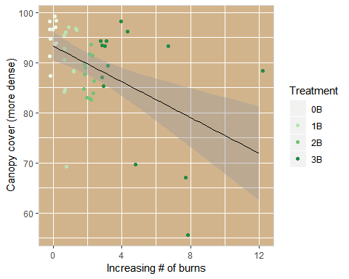

#stat_quantile(data=vdata,quantiles=c(0.025,0.975),formula=Ccover~Nburns,method="rq",geom="quantile"))  
  
plot(Ccover~Nburns,data=vdata)  
abline(ccover.lm)

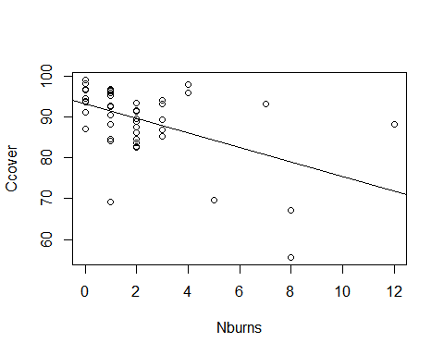

ignore

#1-why are labels and values offset? (NA for 0B)  
  
#vdata$Treatment<-factor(vdata$Treatment, levels=c("OB","1B","2B","3B"),labels=c("OB","1B","2B","3B"))  
  
#confint.lm  
  
#qplot(vdata$Treatment,vdata$Ccover,data=vdata,geom=c("boxplot","jitter"),fill=vdata$Treatment,xlab="Burn Treatments",ylab="Canopy Cover (more to less open)")

vdata <-read.csv("template_pcount_csv.csv")  
  
#print(ggplot(data=vdata,aes(Treatment,Ccover,colour=Treatment))+geom_boxplot(xlab="Burn Treatments",ylab="Canopy Cover (more to less open)")) #notch=TRUE removed #seems to be same as below right now  
  
quantiles_95<-function(x){  
 r<-quantile(x,probs=c(0.025,0.25,0.5,0.75,0.975))  
 names(r)<-c("ymin","lower","middle","upper","ymax")  
 r  
}  
  
ggplot(data=vdata,aes(x=Treatment,y=Ccover,fill=Treatment))+guides(fill=F)+stat_summary(fun.data=quantiles_95,geom="boxplot")+scale_fill_brewer(type="seq",direction=1,palette="Greens")+geom_jitter()+labs(x="Burn treatment",y="Canopy cover (more to less open)")

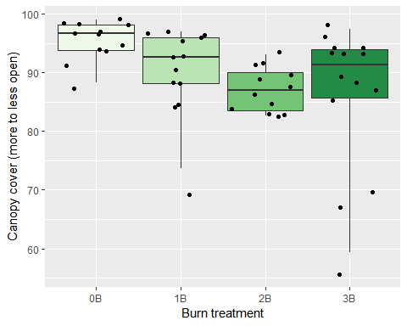

ggplot(data=vdata,aes(x=Nburns,y=Ccover,fill=Treatment))+guides(fill=F)+stat_summary(fun.data=quantiles_95,geom="boxplot")+scale_fill_brewer(type="seq",direction=1,palette="Greens")+geom_jitter()+labs(x="Increasing # of burns",y="Canopy cover (more to less open)")

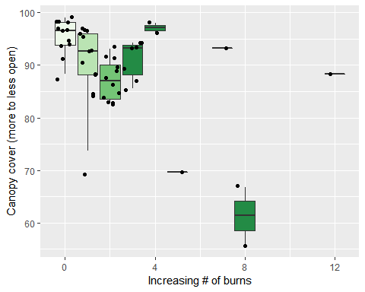

print(ggplot(data=vdata,aes(Nburns,Ccover))+geom_smooth(xlab="Increasing number of burns",ylab="Canopy cover (more to less open)")+geom_jitter())

## Warning: Ignoring unknown parameters: xlab, ylab

## `geom_smooth()` using method = 'loess' and formula 'y ~ x'

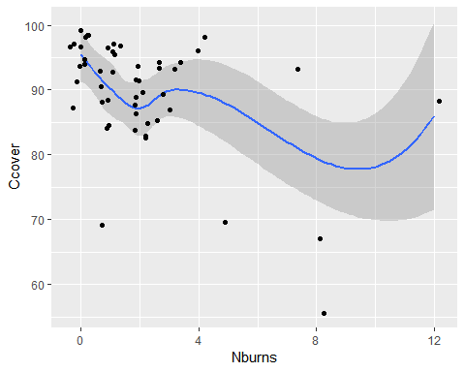

# relative hardwood to pine in the canopy decr but NOT-SIG by treatment

# YES sig dec by #burns

hw2p.lm<-lm(Rel_HW2P_canopy~Nburns,data=vdata)  
summary(hw2p.lm)

##   
## Call:  
## lm(formula = Rel_HW2P_canopy ~ Nburns, data = vdata)  
##   
## Residuals:  
## Min 1Q Median 3Q Max   
## -0.23169 -0.09626 -0.01082 0.07418 0.31831   
##   
## Coefficients:  
## Estimate Std. Error t value Pr(>|t|)   
## (Intercept) 0.231693 0.025936 8.933 7.41e-12 ***  
## Nburns -0.025437 0.008267 -3.077 0.00342 **   
## ---  
## Signif. codes: 0 '***' 0.001 '**' 0.01 '*' 0.05 '.' 0.1 ' ' 1  
##   
## Residual standard error: 0.1387 on 49 degrees of freedom  
## Multiple R-squared: 0.1619, Adjusted R-squared: 0.1448   
## F-statistic: 9.468 on 1 and 49 DF, p-value: 0.003418

confint.lm(hw2p.lm)

## 2.5 % 97.5 %  
## (Intercept) 0.17957258 0.283813194  
## Nburns -0.04204984 -0.008824444

fig<-print(ggplot(vdata,aes(x=Nburns,y=Rel_HW2P_canopy,colour=Treatment))  
 +geom_jitter()  
 +geom_smooth(method=lm,fullrange=TRUE,color="black",size=0.5)  
 +labs(x="Increasing # of burns",y="Relative hardwood to pine (in canopy)")  
 +scale_color_brewer(palette="Greens")+theme(panel.background = element_rect(fill = "tan",colour = "lightgray",size = 0.5, linetype = "solid"))) #or tan1 or lightsalmon1 or navajowhite2

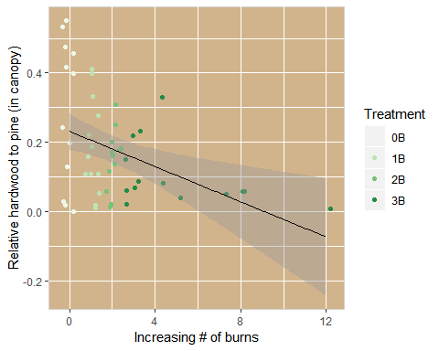

#no treatment fig bc not significant  
  
ggplot(data=vdata,aes(x=Nburns,y=Rel_HW2P_canopy,fill=Treatment))+guides(fill=F)+stat_summary(fun.data=quantiles_95,geom="boxplot")+scale_fill_brewer(type="seq",direction=1,palette="Greens")+geom_jitter()+labs(x="Increasing # of burns",y="Relative hardwood to pine (in canopy)")

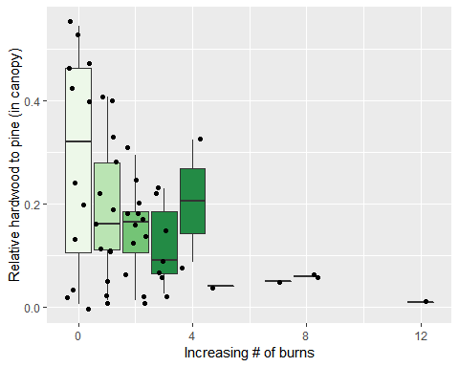

print(ggplot(data=vdata,aes(Nburns,Rel_HW2P_canopy))+geom_smooth(xlab="Increasing number of burns",ylab="Relative hardwood to pine (in canopy)")+geom_jitter())

## Warning: Ignoring unknown parameters: xlab, ylab

## `geom_smooth()` using method = 'loess' and formula 'y ~ x'

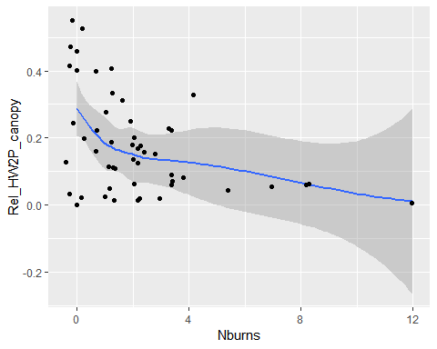

# litter depth sig decreased for 3B,

# decr sig w Nburns

litter.lm<-lm(Ldepth~Nburns,data=vdata)  
summary(litter.lm)

##   
## Call:  
## lm(formula = Ldepth ~ Nburns, data = vdata)  
##   
## Residuals:  
## Min 1Q Median 3Q Max   
## -1.3704 -0.6960 -0.1311 0.7255 2.3176   
##   
## Coefficients:  
## Estimate Std. Error t value Pr(>|t|)   
## (Intercept) 2.34294 0.16089 14.563 < 2e-16 ***  
## Nburns -0.19879 0.05128 -3.877 0.000315 ***  
## ---  
## Signif. codes: 0 '***' 0.001 '**' 0.01 '*' 0.05 '.' 0.1 ' ' 1  
##   
## Residual standard error: 0.8607 on 49 degrees of freedom  
## Multiple R-squared: 0.2347, Adjusted R-squared: 0.2191   
## F-statistic: 15.03 on 1 and 49 DF, p-value: 0.0003153

confint.lm(litter.lm)

## 2.5 % 97.5 %  
## (Intercept) 2.0196259 2.66625575  
## Nburns -0.3018449 -0.09573968

print(ggplot(vdata,aes(x=Nburns,y=Ldepth,colour=Treatment))  
 +geom_jitter()  
 +geom_smooth(method=lm,fullrange=TRUE,color="black",size=0.5)  
 +labs(x="Increasing # of burns",y="Litter depth (cm)")  
 +scale_color_brewer(palette="Greens")+theme(panel.background = element_rect(fill = "tan",colour = "lightgray",size = 0.5, linetype = "solid"))) #or tan1 or lightsalmon1 or navajowhite2

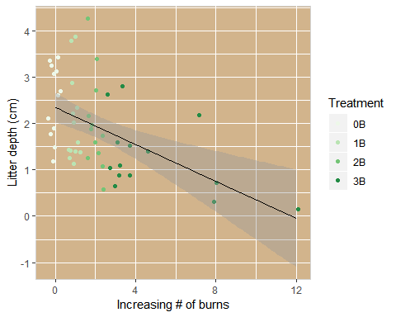

#qplot(vdata$Nburns,vdata$Ldepth,data=vdata,geom=c("boxplot","jitter"),color=vdata$Treatment,xlab="Increasing number of burns",ylab="Litter depth")  
  
#print(ggplot(data=vdata,aes(Nburns,Ldepth,colour=Treatment))+geom_boxplot(xlab="Increasing number of burns",ylab="Litter depth"))  
  
ggplot(data=vdata,aes(x=Treatment,y=Ldepth,fill=Treatment))+guides(fill=F)+stat_summary(fun.data=quantiles_95,geom="boxplot")+scale_fill_brewer(type="seq",direction=1,palette="Greens")+geom_jitter()+labs(x="Burn treatment",y="Litter depth (cm)")

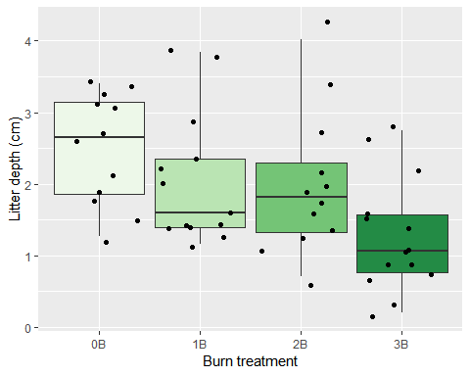

ggplot(data=vdata,aes(x=Nburns,y=Ldepth,fill=Treatment))+guides(fill=F)+stat_summary(fun.data=quantiles_95,geom="boxplot")+scale_fill_brewer(type="seq",direction=1,palette="Greens")+geom_jitter()+labs(x="Increasing # of burns",y="Litter depth (cm)")

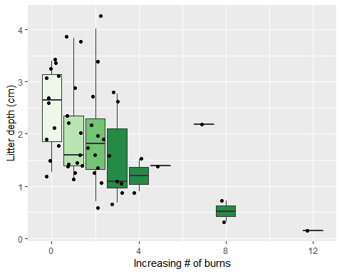

print(ggplot(data=vdata,aes(Nburns,Ldepth))+geom_smooth(xlab="Increasing number of burns",ylab="Litter depth (cm)")+geom_jitter())

## Warning: Ignoring unknown parameters: xlab, ylab

## `geom_smooth()` using method = 'loess' and formula 'y ~ x'

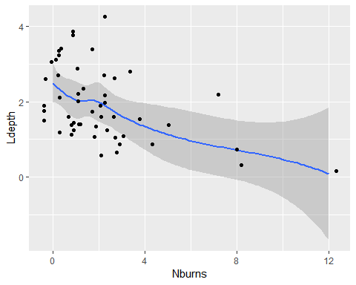

# BA sig decrease for 2B&3B

# sig decrease w Nburns

baT.lm<-lm(BA~Treatment,data=vdata)  
summary(baT.lm)

##   
## Call:  
## lm(formula = BA ~ Treatment, data = vdata)  
##   
## Residuals:  
## Min 1Q Median 3Q Max   
## -39.462 -7.083 0.786 11.478 34.538   
##   
## Coefficients:  
## Estimate Std. Error t value Pr(>|t|)   
## (Intercept) 98.583 4.762 20.701 < 2e-16 ***  
## Treatment1B -9.122 6.604 -1.381 0.173740   
## Treatment2B -19.250 6.735 -2.858 0.006330 **   
## Treatment3B -23.369 6.490 -3.601 0.000762 ***  
## ---  
## Signif. codes: 0 '***' 0.001 '**' 0.01 '*' 0.05 '.' 0.1 ' ' 1  
##   
## Residual standard error: 16.5 on 47 degrees of freedom  
## Multiple R-squared: 0.2469, Adjusted R-squared: 0.1988   
## F-statistic: 5.137 on 3 and 47 DF, p-value: 0.003731

confint.lm(baT.lm)

## 2.5 % 97.5 %  
## (Intercept) 89.00285 108.163820  
## Treatment1B -22.40754 4.163950  
## Treatment2B -32.79885 -5.701146  
## Treatment3B -36.42505 -10.313045

baB.lm<-lm(BA~Nburns,data=vdata)  
summary(baB.lm)

##   
## Call:  
## lm(formula = BA ~ Nburns, data = vdata)  
##   
## Residuals:  
## Min 1Q Median 3Q Max   
## -39.453 -11.953 2.547 7.966 39.770   
##   
## Coefficients:  
## Estimate Std. Error t value Pr(>|t|)   
## (Intercept) 93.2918 3.0254 30.837 < 2e-16 ***  
## Nburns -3.8385 0.9643 -3.981 0.000227 ***  
## ---  
## Signif. codes: 0 '***' 0.001 '**' 0.01 '*' 0.05 '.' 0.1 ' ' 1  
##   
## Residual standard error: 16.18 on 49 degrees of freedom  
## Multiple R-squared: 0.2444, Adjusted R-squared: 0.2289   
## F-statistic: 15.85 on 1 and 49 DF, p-value: 0.000227

confint.lm(baB.lm)

## 2.5 % 97.5 %  
## (Intercept) 87.212117 99.371483  
## Nburns -5.776331 -1.900684

fig<-print(ggplot(vdata,aes(x=Nburns,y=BA,colour=Treatment))  
 +geom_jitter()  
 +geom_smooth(method=lm,fullrange=TRUE,color="black",size=0.5)  
 +labs(x="Increasing # of burns",y="Basal Area")  
 +scale_color_brewer(palette="Greens")+theme(panel.background = element_rect(fill = "tan",colour = "lightgray",size = 0.5, linetype = "solid"))) #or tan1 or lightsalmon1 or navajowhite2

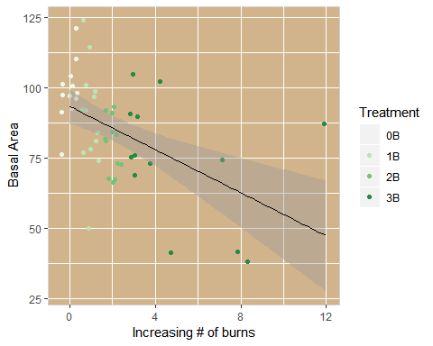

#treatment  
#qplot(vdata$Treatment,vdata$BA,data=vdata,geom=c("boxplot","jitter"),color=vdata$Treatment,xlab="Burn treatment",ylab="Basal area")  
  
#print(ggplot(data=vdata,aes(Treatment,BA,colour=Treatment))+geom_boxplot(xlab="Burn treatment",ylab="Basal Area"))  
  
# number of burns  
#qplot(vdata$Nburns,vdata$BA,data=vdata,geom=c("boxplot","jitter"),color=vdata$Treatment,xlab="Increasing number of burns",ylab="Basal area")  
  
#print(ggplot(data=vdata,aes(Nburns,BA,colour=Treatment))+geom_boxplot(xlab="Increasing number of burns",ylab="Basal Area"))  
  
  
#new  
ggplot(data=vdata,aes(x=Treatment,y=BA,fill=Treatment))+guides(fill=F)+stat_summary(fun.data=quantiles_95,geom="boxplot")+scale_fill_brewer(type="seq",direction=1,palette="Greens")+geom_jitter()+labs(x="Burn treatment",y="Basal area (10-factor)")

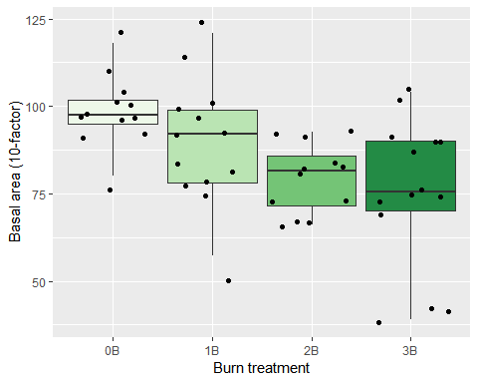

ggplot(data=vdata,aes(x=Nburns,y=BA,fill=Treatment))+guides(fill=F)+stat_summary(fun.data=quantiles_95,geom="boxplot")+scale_fill_brewer(type="seq",direction=1,palette="Greens")+geom_jitter()+labs(x="Increasing # of burns",y="Basal area (10-factor)")

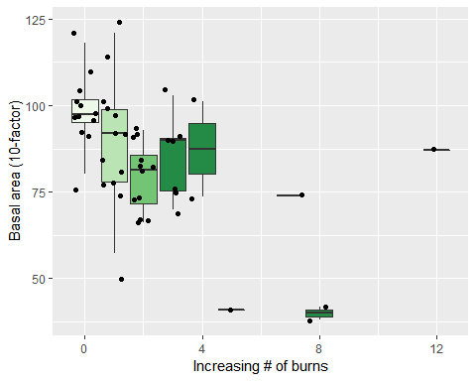

print(ggplot(data=vdata,aes(Nburns,BA))+geom_smooth(xlab="Increasing number of burns",ylab="Basal Area")+geom_jitter())

## Warning: Ignoring unknown parameters: xlab, ylab

## `geom_smooth()` using method = 'loess' and formula 'y ~ x'

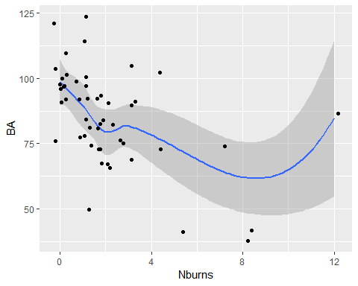

# herbaceous cover at low heights sig increase for 2B&3B

# sig increase w Nburns

fgherbT.lm<-lm(FG_herb~Treatment,data=vdata)  
summary(fgherbT.lm)

##   
## Call:  
## lm(formula = FG_herb ~ Treatment, data = vdata)  
##   
## Residuals:  
## Min 1Q Median 3Q Max   
## -0.5327 -0.1517 -0.0037 0.1888 0.4155   
##   
## Coefficients:  
## Estimate Std. Error t value Pr(>|t|)   
## (Intercept) 0.17975 0.06743 2.666 0.010498 *   
## Treatment1B 0.18679 0.09351 1.998 0.051572 .   
## Treatment2B 0.29517 0.09536 3.095 0.003309 **   
## Treatment3B 0.36895 0.09189 4.015 0.000213 ***  
## ---  
## Signif. codes: 0 '***' 0.001 '**' 0.01 '*' 0.05 '.' 0.1 ' ' 1  
##   
## Residual standard error: 0.2336 on 47 degrees of freedom  
## Multiple R-squared: 0.2751, Adjusted R-squared: 0.2289   
## F-statistic: 5.947 on 3 and 47 DF, p-value: 0.001593

confint.lm(fgherbT.lm)

## 2.5 % 97.5 %  
## (Intercept) 0.044098418 0.3154016  
## Treatment1B -0.001326437 0.3749034  
## Treatment2B 0.103326359 0.4870070  
## Treatment3B 0.184084483 0.5538084

fgherbB.lm<-lm(FG_herb~Nburns,data=vdata)  
summary(fgherbB.lm)

##   
## Call:  
## lm(formula = FG_herb ~ Nburns, data = vdata)  
##   
## Residuals:  
## Min 1Q Median 3Q Max   
## -0.43812 -0.20614 -0.00574 0.20788 0.44947   
##   
## Coefficients:  
## Estimate Std. Error t value Pr(>|t|)   
## (Intercept) 0.27174 0.04220 6.44 4.89e-08 ***  
## Nburns 0.06079 0.01345 4.52 3.92e-05 ***  
## ---  
## Signif. codes: 0 '***' 0.001 '**' 0.01 '*' 0.05 '.' 0.1 ' ' 1  
##   
## Residual standard error: 0.2257 on 49 degrees of freedom  
## Multiple R-squared: 0.2943, Adjusted R-squared: 0.2798   
## F-statistic: 20.43 on 1 and 49 DF, p-value: 3.923e-05

confint.lm(fgherbB.lm)

## 2.5 % 97.5 %  
## (Intercept) 0.18694518 0.35653923  
## Nburns 0.03376349 0.08781948

fig<-print(ggplot(vdata,aes(x=Nburns,y=FG_herb,colour=Treatment))  
 +geom_jitter()  
 +geom_smooth(method=lm,fullrange=TRUE,color="black",size=0.5)  
 +labs(x="Increasing # of burns",y="Herbaceous cover in understory")  
 +scale_color_brewer(palette="Greens")+theme(panel.background = element_rect(fill = "tan",colour = "lightgray",size = 0.5, linetype = "solid"))) #or tan1 or lightsalmon1 or navajowhite2

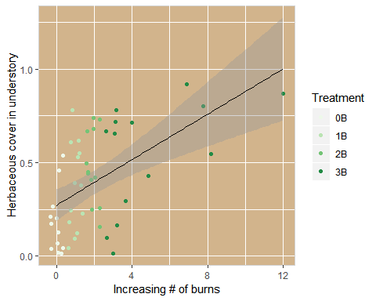

#treatment  
#qplot(vdata$Treatment,vdata$FG_herb,data=vdata,geom=c("boxplot","jitter"),color=vdata$Treatment,xlab="Burn treatment",ylab="Herbaceous cover in understory")  
  
#colour=c("lightgrey","palegreen","green1","darkgreen")  
  
#print(ggplot(data=vdata,aes(Treatment,FG_herb,fill=Treatment))+geom_boxplot(xlab="Burn treatment",ylab="Herbaceous cover in understory")+scale_fill_brewer(type="seq",direction=1,palette="Greens")+geom_jitter())  
  
# number of burns  
#qplot(vdata$Nburns,vdata$FG_herb,data=vdata,geom=c("boxplot","jitter"),color=vdata$Treatment,xlab="Increasing number of burns",ylab="Herbaceous cover in understory")  
  
#print(ggplot(data=vdata,aes(Nburns,FG_herb,fill=Treatment))+geom_boxplot(xlab="Increasing number of burns",ylab="Herbaceous cover in understory")+scale_fill_brewer(type="seq",direction=1,palette="Greens")+geom_jitter())  
  
  
ggplot(data=vdata,aes(x=Treatment,y=FG_herb,fill=Treatment))+guides(fill=F)+stat_summary(fun.data=quantiles_95,geom="boxplot")+scale_fill_brewer(type="seq",direction=1,palette="Greens")+geom_jitter()+labs(x="Burn treatment",y="Herbaceous cover in understory")

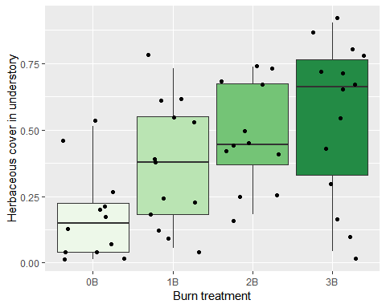

ggplot(data=vdata,aes(x=Nburns,y=FG_herb,fill=Treatment))+guides(fill=F)+stat_summary(fun.data=quantiles_95,geom="boxplot")+scale_fill_brewer(type="seq",direction=1,palette="Greens")+geom_jitter()+labs(x="Increasing # of burns",y="Herbaceous cover in understory")

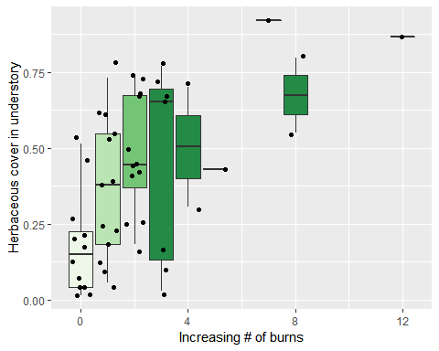

print(ggplot(data=vdata,aes(Nburns,FG_herb))+geom_smooth(xlab="Increasing number of burns",ylab="Herbaceous cover in understory")+geom_jitter())

## Warning: Ignoring unknown parameters: xlab, ylab

## `geom_smooth()` using method = 'loess' and formula 'y ~ x'

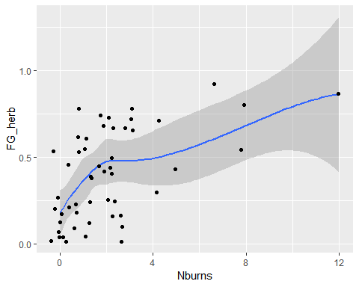

# HW sapling density at low-med heights sig increase for 2B&3B

# sig increase w Nburns

hw1050T.lm<-lm(HW_dens_1050~Treatment,data=vdata)  
summary(hw1050T.lm)

##   
## Call:  
## lm(formula = HW_dens_1050 ~ Treatment, data = vdata)  
##   
## Residuals:  
## Min 1Q Median 3Q Max   
## -43.300 -19.066 -1.296 9.502 66.238   
##   
## Coefficients:  
## Estimate Std. Error t value Pr(>|t|)   
## (Intercept) 26.762 7.031 3.806 0.000407 ***  
## Treatment1B 15.207 9.750 1.560 0.125556   
## Treatment2B 26.738 9.943 2.689 0.009886 **   
## Treatment3B 25.534 9.582 2.665 0.010521 *   
## ---  
## Signif. codes: 0 '***' 0.001 '**' 0.01 '*' 0.05 '.' 0.1 ' ' 1  
##   
## Residual standard error: 24.36 on 47 degrees of freedom  
## Multiple R-squared: 0.1689, Adjusted R-squared: 0.1158   
## F-statistic: 3.184 on 3 and 47 DF, p-value: 0.03229

confint.lm(hw1050T.lm)

## 2.5 % 97.5 %  
## (Intercept) 12.617989 40.90701  
## Treatment1B -4.408177 34.82164  
## Treatment2B 6.734140 46.74086  
## Treatment3B 6.258209 44.80965

hw1050B.lm<-lm(HW_dens_1050~Nburns,data=vdata)  
summary(hw1050B.lm)

##   
## Call:  
## lm(formula = HW_dens_1050 ~ Nburns, data = vdata)  
##   
## Residuals:  
## Min 1Q Median 3Q Max   
## -33.363 -18.465 -4.163 14.846 59.033   
##   
## Coefficients:  
## Estimate Std. Error t value Pr(>|t|)   
## (Intercept) 33.967 4.393 7.732 4.92e-10 ***  
## Nburns 4.798 1.400 3.427 0.00125 **   
## ---  
## Signif. codes: 0 '***' 0.001 '**' 0.01 '*' 0.05 '.' 0.1 ' ' 1  
##   
## Residual standard error: 23.5 on 49 degrees of freedom  
## Multiple R-squared: 0.1933, Adjusted R-squared: 0.1768   
## F-statistic: 11.74 on 1 and 49 DF, p-value: 0.001246

confint.lm(hw1050B.lm)

## 2.5 % 97.5 %  
## (Intercept) 25.138645 42.794976  
## Nburns 1.984176 7.611912

fig<-print(ggplot(vdata,aes(x=Nburns,y=HW_dens_1050,colour=Treatment))  
 +geom_jitter()  
 +geom_smooth(method=lm,fullrange=TRUE,color="black",size=0.5)  
 +labs(x="Increasing # of burns",y="Hardwood seedlings in understory")  
 +scale_color_brewer(palette="Greens")+theme(panel.background = element_rect(fill = "tan",colour = "lightgray",size = 0.5, linetype = "solid"))) #or tan1 or lightsalmon1 or navajowhite2

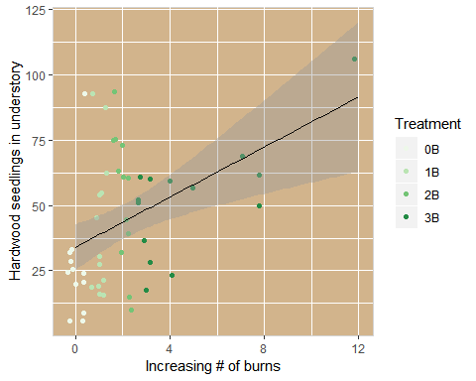

#treatment  
#qplot(vdata$Treatment,vdata$HW_dens_1050,data=vdata,geom=c("boxplot","jitter"),color=vdata$Treatment,xlab="Burn treatment",ylab="Hardwood seedling density in understory")  
  
#print(ggplot(data=vdata,aes(Treatment,HW_dens_1050,colour=Treatment))+geom_boxplot(xlab="Burn treatment",ylab="Hardwood seedling density in understory"))  
  
# number of burns  
#qplot(vdata$Nburns,vdata$HW_dens_1050,data=vdata,geom=c("boxplot","jitter"),color=vdata$Treatment,xlab="Increasing number of burns",ylab="Hardwood seedling density in understory")  
  
#print(ggplot(data=vdata,aes(Nburns,HW_dens_1050,colour=Treatment))+geom_boxplot(xlab="Increasing number of burns",ylab="Hardwood seedling density in understory"))  
  
ggplot(data=vdata,aes(x=Treatment,y=HW_dens_1050,fill=Treatment))+guides(fill=F)+stat_summary(fun.data=quantiles_95,geom="boxplot")+scale_fill_brewer(type="seq",direction=1,palette="Greens")+geom_jitter()+labs(x="Burn treatment",y="Hardwood seedling density in understory")

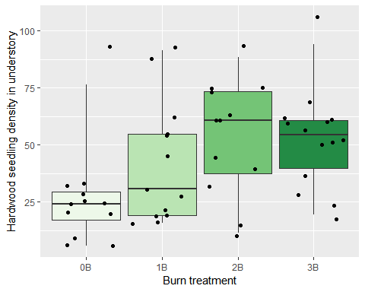

ggplot(data=vdata,aes(x=Nburns,y=HW_dens_1050,fill=Treatment))+guides(fill=F)+stat_summary(fun.data=quantiles_95,geom="boxplot")+scale_fill_brewer(type="seq",direction=1,palette="Greens")+geom_jitter()+labs(x="Increasing # of burns",y="Hardwood seedling density in understory")

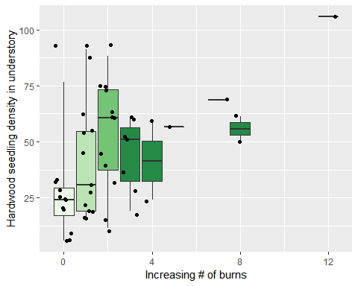

print(ggplot(data=vdata,aes(Nburns,HW_dens_1050))+geom_smooth(xlab="Increasing number of burns",ylab="Hardwood seedling density in understory")+geom_jitter())

## Warning: Ignoring unknown parameters: xlab, ylab

## `geom_smooth()` using method = 'loess' and formula 'y ~ x'

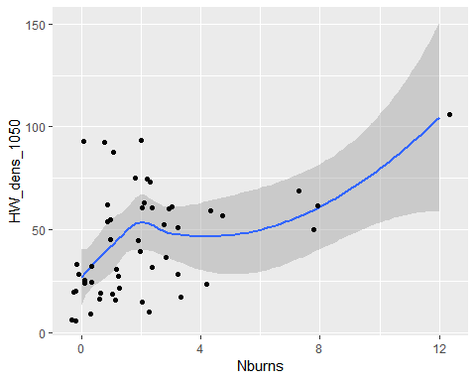

# thins and age were correlated

fig<-plot(Nthins ~ Age, vdata)  
abline(lm(vdata$Nthins ~ vdata$Age),col="blue")

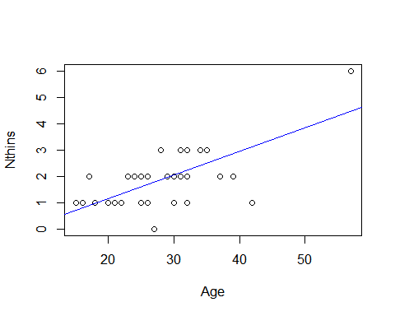

cor.test(vdata$Nthins,vdata$Age) #r=0.702

##   
## Pearson's product-moment correlation  
##   
## data: vdata$Nthins and vdata$Age  
## t = 6.9024, df = 49, p-value = 9.395e-09  
## alternative hypothesis: true correlation is not equal to 0  
## 95 percent confidence interval:  
## 0.528879 0.819200  
## sample estimates:  
## cor   
## 0.7021273